MINISTRY OF SCIENCE AND EDUCATION NATIONAL TECHNICAL UNIVERSITY “KHARKIV POLYTECHNIC INSTITUTE”

DEPARTMENT OF SOFTWARE ENGINEERING AND MANAGEMENT INFORMATION TECHNOLOGIES

Report from lab#5

Discipline “Fundamentals of DataBase”

Executed by: Student of group 1.КН.201.8г

CHUKWU IRELE AMORIN

Checked by:

**Assistant Polovinka O.L.**

Kharkiv

2019

**TOPIC :**LEARN DBMS ACCESS REPORT DEVELOPMENT TOOLS

**Goal:** State the laboratory practice problem. Study how to Create reports for the queries using the commands

Report 1:

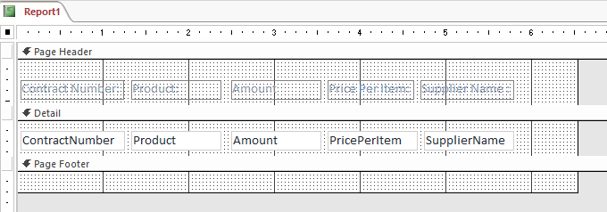

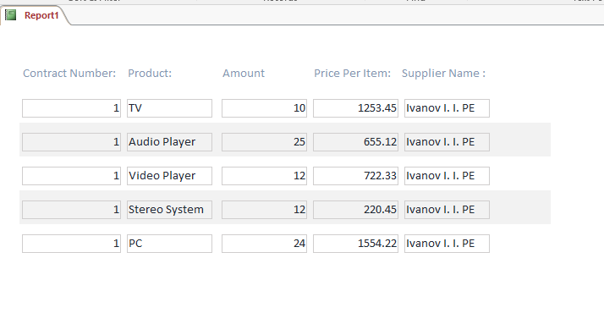

Report 2:

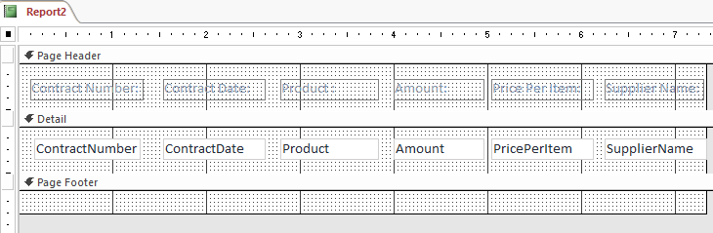

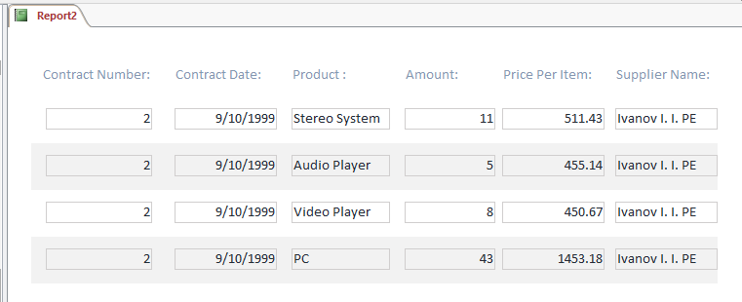

Report 3 :

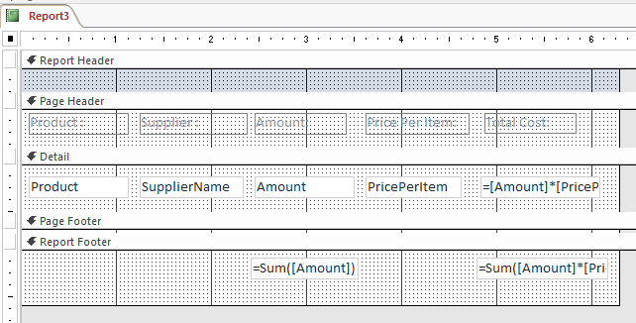

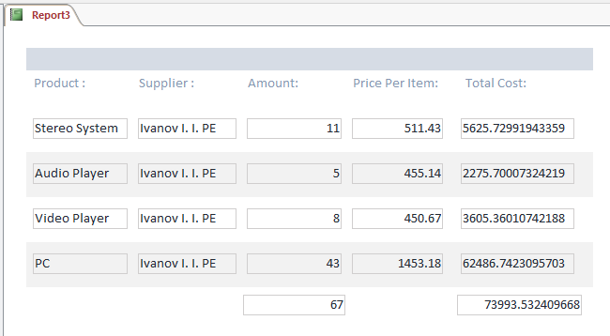

**Conclusion :**

At that lab were received knowledges about BASIC SQL DATA MANIPULATION COMMANDS, it`s usage and gotten practical skills that allows To create raport to print reselt of queries and creat tab in the Access window using DBMS Access in this environment.